**INSTRUCTION MANUAL**

**MY RECIPE FINDER**

**INSTRUCTION MANUAL**

***Table of Contents***

[**1.0 GENERAL INFORMATION** 3](#_Toc495176788)

[**1.1 System Overview** 4](#_Toc495176789)

[**2.0 SYSTEM SUMMARY** 5](#_Toc495176790)

[**2.0 SYSTEM SUMMARY** 6](#_Toc495176791)

[**2.1 System Configuration** 6](#_Toc495176792)

[**2.2 User Access Levels** 6](#_Toc495176793)

[**3.0 GETTING STARTED** 7](#_Toc495176794)

# **1.0 GENERAL INFORMATION**

**1.0 GENERAL INFORMATION**

General Information section explains in general terms the system and the purpose for which it is intended.

## **1.1 System Overview**

My recipe Finder allows users to access an online recipe database to search for different recipes. The application also saves users own recipes to a database and allows them to be viewed, deleted and updated. My Recipe Finder will operate on most mobile devices running the Android operating system. An internet connection is needed to search recipes but the saved recipes can be saved, viewed, updated or deleted without one.

## **1.2 Understanding this Manual**

The following instruction manual is broken into four different sections: General Information, System Summary, Getting Started and Using the Application.

General Information lets users know the basic overview and the intended use of the application.

System Summary will cover system specifications such as system’s hardware and software requirements, system’s configuration and any user restrictions.

Getting started will cover to install and get the application.

Using The Application will explain in detail the system functions.

# **2.0 SYSTEM SUMMARY**

**2.0 SYSTEM SUMMARY**

## **2.1 System Configuration**

The My Recipe Finder Application is compatible with any android mobile device capable of running at least Android 4.1 (Jelly Bean) API Level 16 or higher. It requires an internet connection to work with the recipe search that runs via the webveiw. The application once installed will require permissions to use your apps external storage, other than these permissions no other configuring is needed.

## **2.2 User Access Levels**

No user restrictions apply, except if the user wishes to share or save an online recipe then they will need to sign up for a Food2Fork account.

## **2.3 Contingencies**

If no internet connection available searching of recipes will be unavailable. If the mobile device powers of any unsaved recipes will be lost.

# **3.0 GETTING STARTED**

# **3.0 GETTING STARTED**

## **3.1 Installation**

Installation of the My Recipe Finder app can at present be done by email You can request an email of the APK package on your phone all that is required is for you hit install or the APK attachment, users may be asked for permission to install from unknown source on agreeing the app will be immediately installed future releases may be found in the google play app store.

## **3.2 System Menu**

The My Recipe Finder application is a tabbed application that has three tabs that are swipe able or clickable from the three corresponding icons present at the top of all tabs. The first tab handles the displaying of recipes, the second shows you your recipes in a list and the third allows the user to interact with the app to add, update, delete, view one recipe.

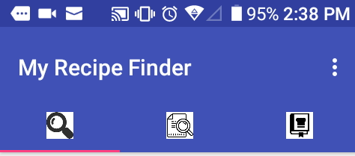

Figure 1: Tabbed Menu

### **C:\Users\Michelle\AppData\Local\Microsoft\Windows\INetCache\Content.Word\2017_10_08_14_38_15.png3.2.1 Recipe tab**

The Recipe Search tab consists of a webview and a refresh button. The food to fork website will be automatically loaded in the webview other sites are only available if clicked on links are part of the Food2Fork site. While in the webview the user can use the devices default back button to go back to a previous webpage.

Figure 2: Recipe Tab

### **3.2.2 View all tab**

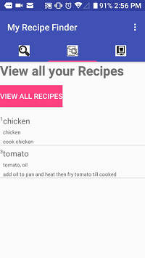The view all tab consists of a button and a list of all the saved recipes in the data base users only need to press the view all button to refresh the list

### Figure 3: View All Your Recipes

### **3.2.3 Cookbook tab**

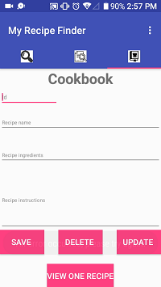The Cookbook tab consists of 4 editable text areas that will take input from the user. These are id for the recipe id should be numeric, the name of the recipe, a list of the ingredients and the required steps that need to be taken to cook and prepare the recipe.

Figure 4: Cookbook tab

## **3.3 Exit the System**

Exiting can be done by hitting your devices Normal exit button.

**4.0 USING THE APPLICATION**

## **4.0 USING THE APPLICATION**

Details all of the system functions.

### **4.2.1 Recipe tab**

This is the opening page of the app when the app is loaded and an internet connection is available, the page will automatically load the required website Food2Fork. The user should then scroll the screen down or up to find a recipe they may like they can enter a search word to filter the results if required. The site will load the filtered results for the user then the user cab select a recipe they like and look at it for the steps they may need to click on the link saying for instructions go to recipe site, once clicked the recipes site will be loaded with full instructions.

### **4.2.2 View All tab**

The view all tab is activated by clicking the button situated at the top of the page, once clicked a list of the recipes saved can be viewed.

### **4.2.3 Cookbook tab**

This tab is where you save your recipes to the database firstly you will need to enter an Id number if you choose a duplicate id it will not insert. If you cannot remember which id’s are in the system you can check the view all page by following the above instructions it will show you the id of all recipes in the system. Then enter a name for your recipe in the name box, then the list of ingredients in the ingredients box and lastly type the steps in to finish your recipe. Once finished writing in your recipe press save to add to the database. If you want to delete a recipe you only need to type in the id number and press delete to view a recipe the same is needed just type the id in and press view if you want to update your recipe you will need to view it then just type in the corrections and press update.